Project Name: Automatic Light Control
Group members: Afra Asad (02-134241-092)
Saba Shahid (02-134241-048)
Aiesha Asad (02-134241-008)
Munesha (02-134241-070)

Introduction
The Automatic light control system
The Automatic Light control system is an progressive and energy-efficient solution that automates lights based totally on particular situations, including door activity. This system removes the need for manual switching by using the usage of a sensor-based mechanism that detects the opening or closing of a door. The layout guarantees that lights are activated most effective when essential, retaining energy whilst presenting comfort. stimulated by way of realistic implementations, this venture integrates simple yet effective components like a comparator, timer IC, and output devices. The system is ideal for use in homes, workplaces, and public spaces in which lighting fixtures automation is a concern.

Hardware used

- Door Switch (Normally Closed - NC):
  - Detects the door’s state (open or closed).
- Comparator (LM741 IC):
  - Compares the voltage from the door switch with a reference voltage to generate a HIGH or LOW output.
- 555 Timer IC:
  - Functions as a pulse generator to control the activation duration of the light or buzzer.
- Resistors:
  - R1 (10 kΩ): Pull-down resistor to stabilize the comparator input and prevent false triggering.
  - R2 (1 kΩ): Used with the 555 Timer to define the RC time constant.
  - R3 (470 Ω): Current-limiting resistor for the LED (if used as an output indicator).
- Capacitors:
  - C1 (10 µF): Smoothing capacitor for the power supply.
  - C2 (0.1 µF): Noise suppression capacitor near the ICs.
  - C3 (1 µF): Timing capacitor used in the 555 Timer to define the output pulse duration.
- 555 Timer Configuration:
  - The output pulse duration (time for which the light stays ON) is calculated using the formula:
T = 1.1 × R2 × C3
For example:
    - If R2 = 1 kΩ and C3 = 1 µF, the output pulse duration T = 1.1 × 1000 × 0.000001 = 1.1 ms.
Adjust R2 and C3 values based on the desired light activation time (e.g., longer durations require larger resistors or capacitors).
- Relay Module:
  - Switches the high-power load (light bulb or buzzer) based on the output of the 555 Timer.
- Light Bulb/Lamp:
  - Voltage Rating: 12V (or match it with the relay output voltage).
  - Power Rating: 5W or as required for your application.
  - Ensure the lamp's power matches the relay's capacity to avoid overloading.
- Buzzer (Optional):
  - Voltage Rating: 5V or 12V (depending on the system design).
- Power Supply:
- ICs and Logic Circuit: 5V DC (regulated).
- Relay and Light Bulb: 12V DC (for switching and output).
- Breadboard/PCB:
  - For mounting and connecting components.
- Connecting Wires:
  - For establishing electrical connections between components.

objective
The main objectives of this project are:

Automated light control:
To automate the switching of lighting fixtures based totally on door activity the usage of a sensor-based totally mechanism.
Energy Conservation:
Reducing electricity intake by using ensuring lights are only ON while the door is opened and off while the door is closed.
Low-cost Implementation:
To design a device using low-cost and easily available electronic additives.
Ease of installation:
To increase a device that may be installed in any environment without complex configurations.
Scalability:
To enable future upgrades like integrating motion sensors or ambient light sensors for greater advanced control.

Block Diagram

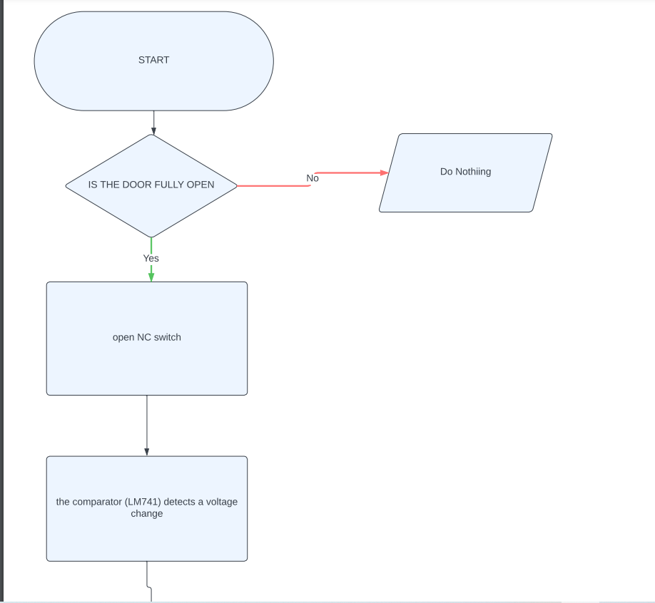
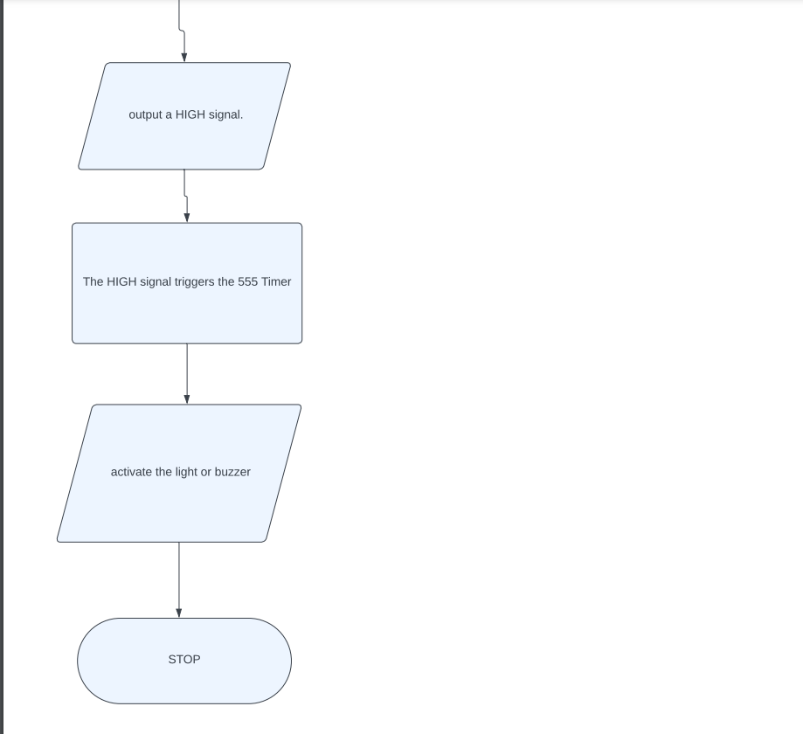

Methodology
- Setup the Door Switch (NC):
  - Mount the switch at a position where it opens only when the door is fully pushed against the wall.
  - Ensure proper wiring from the switch to the comparator circuit.
- Comparator Design:
  - Use the LM741 operational amplifier.
  - Set up one input of the LM741 with a reference voltage.
  - Connect the other input to the door switch's output to detect voltage changes when the switch opens or closes.
- Timer Circuit Configuration:
  - Use the 555 Timer IC in monostable mode.
  - Connect the output of the comparator to the trigger input of the timer.
  - Configure the timer to maintain the output (light/buzzer) active for a predefined duration.
- Output Stage:
  - Connect the 555 Timer's output to the light or buzzer circuit.
  - Ensure the light or buzzer activates when the timer output goes HIGH.
- Testing:
  - Open the door fully and observe if the light/buzzer activates.
  - Ensure the light/buzzer turns off after the timer's duration.
  - Test the system when the door remains closed to confirm no false activations.
- Finalization:
  - Fine-tune the timer's duration as required.
  - Securely mount all components and ensure reliable operation under different conditions.

Working
- Door Switch (NC) Activation:
  - The system starts in its default state, with the door switch (Normally Closed) maintaining a closed circuit.
  - When the door is fully opened and pushed against the wall, the switch opens, disrupting the circuit.
- Comparator Operation:
  - The comparator (LM741) detects a change in voltage caused by the opening of the door switch.
  - It compares the voltage from the switch with a reference voltage.
  - If the switch opens, the comparator output goes HIGH.
- 555 Timer Trigger:
  - The HIGH signal from the comparator triggers the 555 Timer, which is configured in monostable mode.
  - The timer output remains HIGH for a fixed duration, set by external components (resistor and capacitor).
- Light/Buzzer Activation:
  - The HIGH output from the 555 Timer activates the light or buzzer, providing an alert that the door is fully opened.
  - After the timer completes its cycle, the output goes LOW, deactivating the light/buzzer.
- System Reset:
  - When the door is closed, the switch returns to its normally closed state.
  - The comparator output goes LOW, and the system is ready for the next cycle.

Applications
- Home Automation:
  - Alerts residents when doors are left open, enhancing security and convenience.
- Retail and Commercial Settings:
  - Monitors entry or exit points in shops, warehouses, or offices.
- Industrial Use:
  - Ensures critical doors or enclosures are securely closed, improving safety in factories or workshops.
- Public Buildings:
  - Helps track door states in schools, hospitals, or government buildings.
- Security Systems:
  - Integrates with alarms to notify unauthorized or unexpected door openings.

Conclusion
The Automatic Door Switch System is an effective and practical solution for monitoring door states. It ensures that an alert is generated whenever a door is fully opened, making it highly useful for both residential and commercial applications.
The use of simple and reliable components like the door switch, comparator, and 555 Timer ensures cost efficiency and ease of maintenance. The system's versatility allows it to be adapted to various use cases, from home automation to industrial safety.
By automating door state monitoring and alerting, this project highlights the importance of electronics in enhancing convenience, safety, and security.

